What is an API?

API stands for Application Programming Interface; in effect it is the middleman that allows two applications to talk to one another. For example, when you are on your phone or computer and you try and assess a website, your request is sent to a sever, the server then sends the information back to the application that you are using, which then presents the information to you. This action is made possible via an API. API’s can also communicate between server to server, server to developer or as in the above example, client to server.

Looking at this from a practical standpoint, let us say you are designing a new mobile application that requires the user’s location, instead of having to create google maps again from scratch, you can connect your app to google maps API which will add the desired functionality. Most large companies have made their APIs for various functionality open sourced, which means they can be used by anybody.

For our minor project we used Pushing-Box to write the values created by the sensors connected to our Arduino Yun to a spreadsheet. This was our first steps into the world of working with API’s. Our goal for our major project was to create a simple user interface that the device could be controlled from. As part of our course, we have examined multiple API’s, I am now going to examine each one to better inform our choice moving forward in our project.

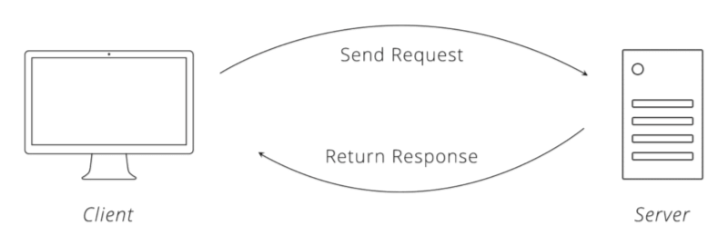

Pushing Box

Pushing box is a simple API that has a lot of functionality, the service can be triggered via HTTP requests or emails, it allows a device to connected to a host of web services to store data or generate notifications. In our minor project we used the service to write the sensors values created by our Arduino to a spreadsheet. The service can also be used to generate notifications via emails and twitter.

With our goal of creating a user interface in mind, PushingBox may not be a suitable as the other two API’s. It is a very powerful service, and we only scraped the surface of its functionality for our minor project, its something we could re-examine for a future project idea.

Rest

Rest stands for Representational State Transfer, a rest API or a restful API is the most popular API in the software development industry, A report conducted by cloud elements in 2017 stated that 83% of APIs in use now use rest.

In short rest is a set of architectural standards relying on HTTP requests that dictate how the two connected applications communicate with each other. This standardized way of commutation means that that no matter how the server operates or how the application is coded, if both are communicating according to rest architecture guidelines, any client can operate with any server, which simplifies storing and receiving data.

During our lab time we used rest to activate ports on the Arduino with the requests being controlled from a standard HTML page. We discussed created a web-based application for our project and using this as a controller for the monitor. We were confident that this would work for our project but wanted to explore further options, this brought us on onto Blynk.

Blynk

Using cloud technology Blynk allows you to control a device remotely from your phone, unlike rest, your phone can be connected to a different network and it can still communicate with the device you are using. This is possible as the request created by the app is sent to a server and then is sent back to your chosen device which is connected to the sever by the ID created by the app.

This makes setting up a user interface very simple and quick, and we can add in the features that we want to control of monitoring device effectively.

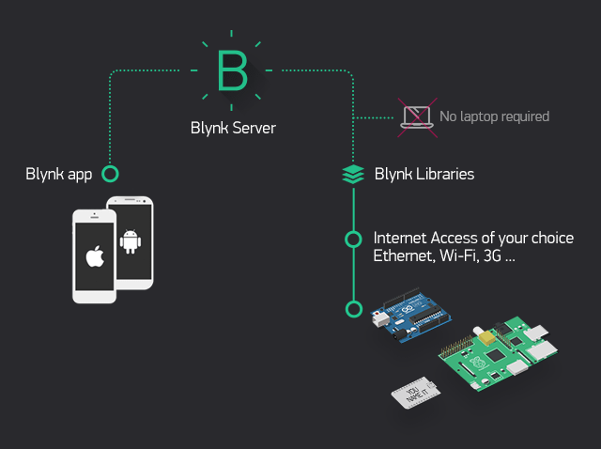

Our choice

After exploring our options, we decided to use Blynk to create our user interface, With the given time frame for our project we felt that we could create a working user interface quickly and begin testing the baby monitor. Also, the fact that the phone acting as the controller and the Arduino did not have to be connected to the same network simplified the process further.

Sources

Michelle, (June 10,2016), “PushingBox API: Real Time Nonfictions For IOT Devices” viewed 24/04/21, <https://revolution11blog.com/2016/06/10/pushingbox-api-real-time-notifications-for-iot-devices-part-2/>

Rina Schiller, unknown, “Identify the advantages of a rest API”, viewed 24/04/21, <https://openclassrooms.com/en/courses/6121936-build-your-web-projects-with-rest-apis/6268221-identify-the-advantages-of-a-rest-api>

Unknown, Unknown, “How Blynk Works” viewed 24/04/21 https://docs.blynk.cc/#:~:text=It%20can%20control%20hardware%20remotely,using%20various%20widgets%20we%20provide